



**SM6P07NI Digital Media Project**

**20% Report**

**2019-20 Autumn**

**Student Name: Bibek Dhungana**

**London Met ID: 20049286**

**College ID: np01mm4s210075**

**External Supervisor: Pooja Shrestha**

**Internal Supervisor Rakhshak Bajracharya**

**Assignment Due Date:** Click or tap to enter a date.

**Assignment Submission Date:** Click or tap to enter a date.

**Word Count:**

*I confirm that I understand my coursework needs to be submitted online via Google Classroom under the relevant module page before the deadline in order for my assignment to be accepted and marked. I am fully aware that late submissions will be treated as non-submission and a marks of zero will be awarded.*

Abstract

This documentation is the final documentation of this module Digital media project.  
This documents provides the all the information of my DMP project. My project is about Gaming environment. The title of my animation is The adventure of the rock. This concept is inspired of the god of war.

The origins of 3D games began in 1974. First elements of the technology appeared in “Maze War” and “Spasim” (shortened from Space Simulation). The developers tried to experiment with the dimensions: in “Maze War,” players were allowed to move not only left and right but also forward and backward, and shoot in all four directions. In “Spasim” it was possible to fly spaceship between different galaxies and see other players flying around (in three dimensions) as well.

This documentation gives all the research and proof of my gaming environment project of DMP.

**Contents**

1 Introduction 1

1.1 Topic 1

1.2 Area of Research 1

2 Aims of Project 2

3 Target Audience 3

4 Product Research 4

5 Technologies Employed 5

6 Project Plan 6

7 Production Phases 7

8 Resources 8

9 User Testing & Findings 9

10 Conclusion 10

11 References 11

12 Bibliography 12

13 Appendix 13

# Introduction

This documentation provides the information regarding the 2nd coursework of dmp. The coursework covers 20% if the total assignment. In previous documentation if of Digital Media Project (DMP) which is second and final of project of this year which is final.

This document covers all the details of my project of gaming environment whose topic is the adventure of the rocks. It covers the target audience, technologies employed and the resources and techniques used to deliver the final product.

## Topic

**“The adventure of the rocks”**

This title is inspired from the famous action adventure called the god of war. The main thing about this topic is to show a environment which is a little adventurous. The whole project modelling would be looking like a traditional place place which is covered by hills rocks and stones. Like the remote mountainous region of country.

## Area of Research

*Mention the main research topic here what were research upon before concluding what was required for the final outcome.*

# Aims of Project

My environment consists of various shaped and sized of architectural object like large rocks small hills and a bridge. All this object is inspired from a game called God of war. This environment can also be representation of adventurous game. This all the environment is like semi realistic environment.

The main aim of this project is to creating a traditional gaming environment that is influenced by a famous games whose genre is adventurous and action kind of. The mainly modelling is don’t with the help of Autodesk maya. This project will consist of the final render of the animation in auto desk maya. The main aim of the project is to build a semi realistic gaming environment which is relevant to the title of my project.

Mainly all the assets will be model done by my self which will make the project more relevant because the main point is this project is to make us understand by going through the process of 3d modelling in a professional way.

In conclusion, the main aim of the creating the environment which can used for the gaming environment for the gaming environment. The project is inspired from the famous game god of war and a little bit mixture/taste of the nepali environment on the rocky or hilly side of the Nepal.

# Target Audience

## 3.1 Primary Target audience: Environment Artists and game enthusiast.

**Age**: 15-45 years

**Gender:** All genders

**Genre Specification:** Adventure/Action

**Nationality:** All Nationality

## 3.2 Secondary Audience: Gamers.

Age: 14-40 years.

**Gender:** All genders

**Genre Specification:** Adventure/Action

**Nationality:** All Nationality

# Product Research

*Mention the contents researched upon which was used to develop the final product. This may include theories, techniques, new media practices and similar product reviews. Note: This should be different than the Literature Review and Product Review Contents.*

# Technologies Employed

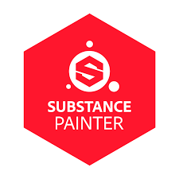



* **Autodesk Maya**

Autodesk Maya was used to model and texture different assets for the project.

* **Substance Painter**

The main object’s who needs lots of detail to look semi realistic the texturing is done from substance painter.

* **Blender**

The environment or just some surface was made with the help of blender.

The majority thing will be don’t with the help of Autodesk maya like rendering also.

# Project Plan

*Mention the initial plan that was done, mention what was used as a prototype/test scene and how the final product had been decided.*

*Also mention what changes had to be done before you completed the final product in this section. (Compare old Timeline with New Timeline).*

# Production Phases

## Pre-Production

## 7.2 Story/Idea

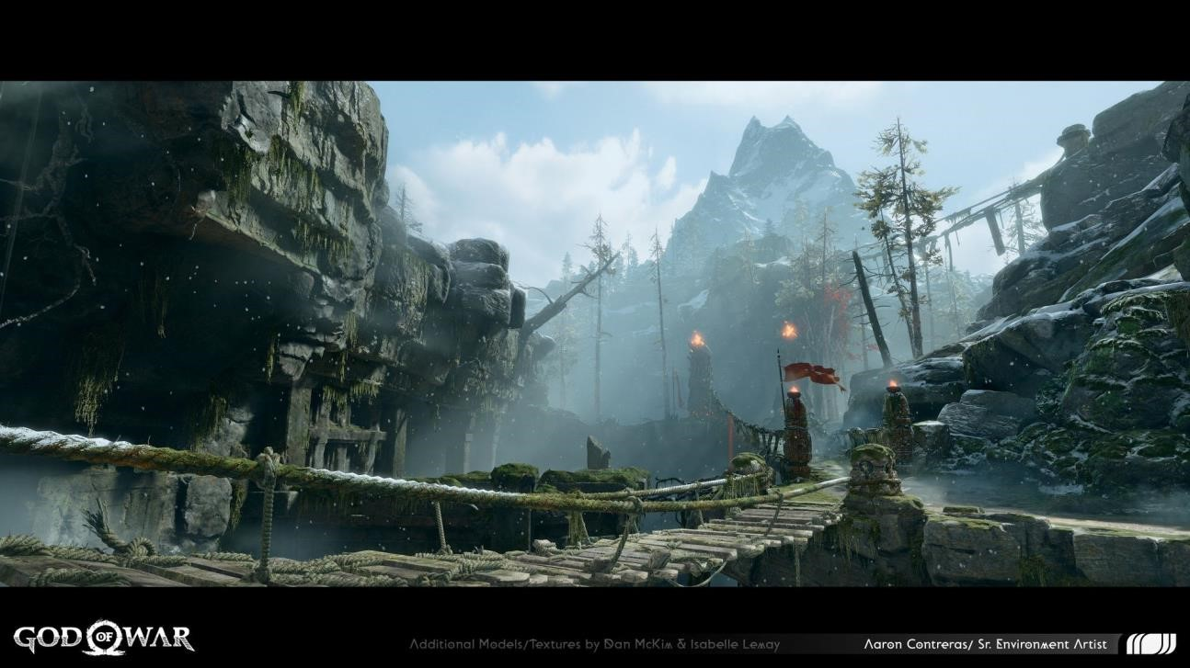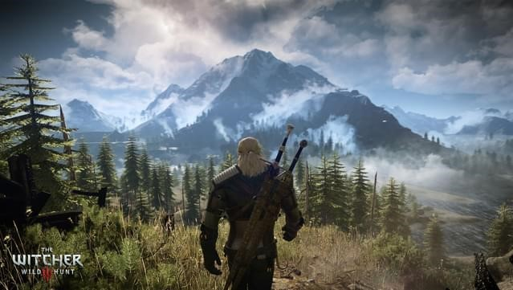

## 7.3 Phase 2: Conceptual Analysis 7.4 Phase 3: Game Planning

7.7.1 Modelling/ Asset Creation

**7.7.1.1 Trees Modelling**

# Resources

## Hardware and Devices:

* Gigabyte g24f.
* Lenovo Legion 5 with NVIDIA GTX 1650ti.

## 8.2 Software



*List out the Hardware and Software Tools used to complete the project and mention if additional tools had to be used than what was mentioned in the Proposal. You are to also mention the Research and Testing Tools here.*

# User Testing & Findings

*Mention the Tests that were conducted among the users and mention the finding in detail in this section.*

# Conclusion

*Mention the overall conclusion of the project, things that were covered in this documentation and what this project has accomplished. (Note: You are not to mention your experiences here)*

# References

*List all your references here with direct citation. (Words not counted)*

# Bibliography

*List all your bibliographies here which you researched about that indirectly helped you to understand the concept to carry out your project. (Words not counted)*

# Appendix

*Keep all your supporting documents such as Gantt Chart, Survey Results, Interview and other details here (Words not counted)*